**Problem Set 4 (Due 3/25/2025 before class in stapled A4-sized paper)**

**Late homework will NOT be accepted, unless you have notified the course instructor 3 days BEFORE deadline.**

**Part I (60%)**

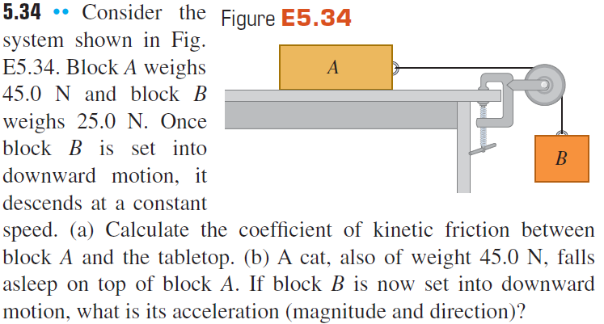



**图表

AI 生成的内容可能不正确。**

**Part II (40%)**

For problems 1-3. In the following figures each of the suspended blocks has weight w. The pulleys are frictionless and the ropes have negligible weight. Calculate, in each case, the tension T in the rope in terms of the weight w. In each case, include the free-body diagram or diagrams you used to determine the answer.

1. One block of weight *w* hanging through a pulley
2. Two blocks of weight *w* hanging through a pulley
3. Two blocks of weight *w* hanging through two pulleys

图示

AI 生成的内容可能不正确。 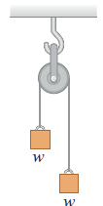文本

AI 生成的内容可能不正确。

*Problem 1 Problem 2 Problem 3*

For Problems 4-5. Three sleds are being pulled horizontally on frictionless horizontal ice using horizontal ropes (see Figure below). The pull is of magnitude 125 N.

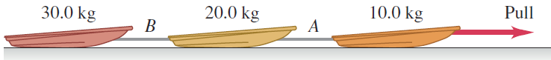

1. Find the acceleration of the system
2. Find the tension in ropes A and B.
3. Two masses are hung over a mass-less and friction-less pulley as shown. What is the resulting acceleration of the system?

形状

AI 生成的内容可能不正确。

1. A box slides down a frictionless inclined plane. It makes an angle of 40 degrees with the horizontal. What is the acceleration of the box as it slides down the incline?
2. Consider a 100 N weight hanging from two cables attached to walls as shown below on the left. Calculate the tension/force in the second cable, T2

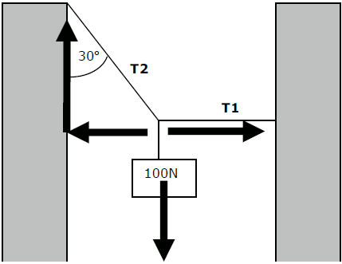 图片包含 图表

AI 生成的内容可能不正确。

1. Two crates connected by a rope lie on a horizontal surface (see the figure above on the right). Crate A has mass mA and crate B has mass mB The coefficient of kinetic friction between each crate and the surface is μk The crates are pulled to the right at constant velocity by a horizontal force ***F***. In terms of μk, mA and mB, calculate the tension in the rope connecting the blocks. Include the free-body diagram or diagrams you used to determine each answer.
2. In the swing, the seat is connected to two cables as shown in the figure, one of which is **horizontal**. The seat swings in a **horizontal** circle at a rate of 32.0 rpm (revolutions/min). If the seat weighs 255 N and an 825-N person is sitting in it, find the tension in each cable.

